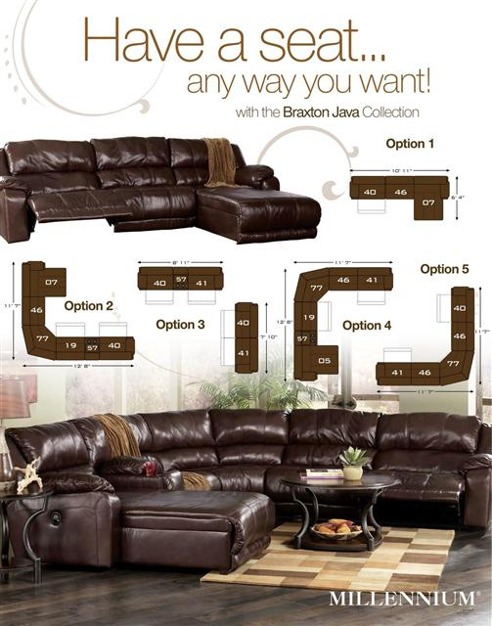
Sofa Sale Price w/3 Recliners $1499 – Disc. Low Stock Left
Sofa Sale Price w/2 Recliners & Pressback Chaise $1699 – Disc. Low Stock Left
Sectional Sale Price w/2 Recliners and Pressback Chaise (Allow 10 Ft. on each side)
(On Display at our Showroom) $2299
97800 Braxton Java leather Sectional by Millennium Signature Design, offers 100% Top Grain Leather in all seating and arm top areas with the benefit of protection and a durable faux leather match across the backs and sides. This contemporary design features the comfortable feel of plush pillow top arms, divided bustle back cushioning and scoop chaise pad seating perfect for any relaxing living room environment. The smooth leather surface offers a light surface correction which allows for the visibility of natural leather grain while the subtle two-tone effect enhances color depth and vibrancy. Braxton is a Protected Leather and is perfect for active households. This model features metal drop-in unitized seat box for strength and durability plus an all metal construction to the floor for strength and durability. The reclining mechanism features infinite positions for comfort and "zero wall technology" - place it within 4 inches of any wall and recline to the furthest position without touching!
9780005 Left Hand Facing Pressback Chaise 44"W x 76"D x 40"H $799
9780007 Right Hand Facing Pressback Chaise 44"W x 76"D x 40"H $799
9780019 "Zero Wall" Armless Recliner 37"W x 42"D x 40"H $449
9780046 "Zero Wall" Armless Chair 37"W x 42"D x 40"H $379
9780040 "Zero Wall" Left Hand Facing Recliner 44"W x 42"D x 40"H $539
9780041 "Zero Wall" Right Hand Facing Recliner 44"W x 42"D x 40"H $539
9780057 Console w/Storage and Two Cupholders 13"W x 42"D x 40"H $219
9780077 Wedge 76"W x 42"D x 40"H $549

